**Data Visualization**

**Airbnb And Zillow Data Challenge**

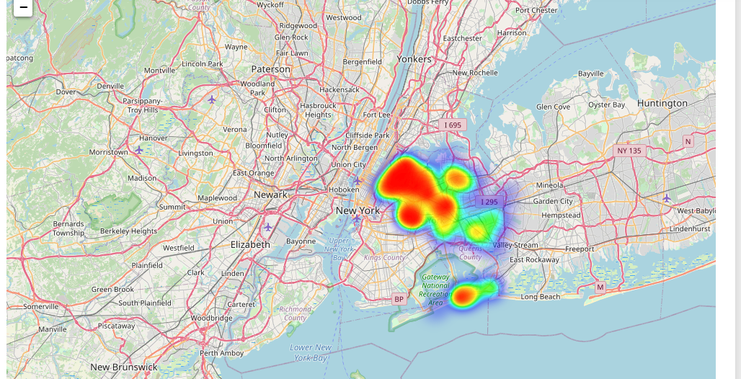

Map showing areas wrt high prices.

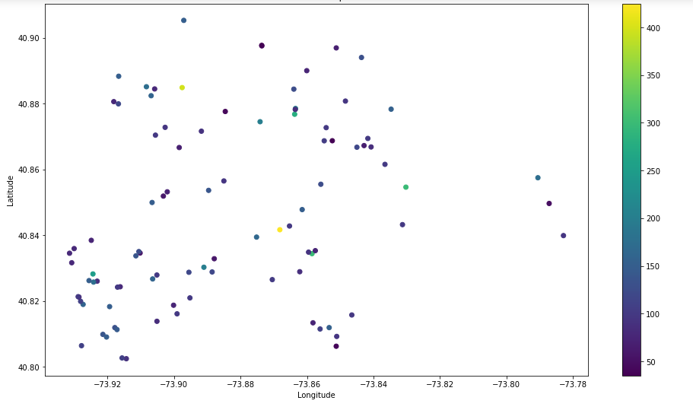

The above scatterplot is another form of representation for Bronx neighborhood group showing central and left areas as most in demand and of less prices. We can do similar scatter plots on map for the other neighborhood groups.

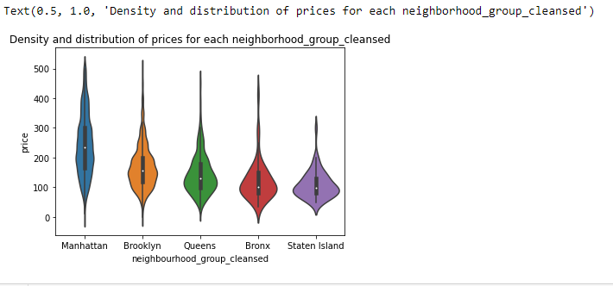

A summarized price distribution will give a clearer picture of which places are charged most and which don’t.

The distribution of neighbourhood_group wrt 2 bedroom apartments shows that Manhattan has prices varying much more than other places. On the contrary, Staten Island has less fluctuation in prices in most of its areas.

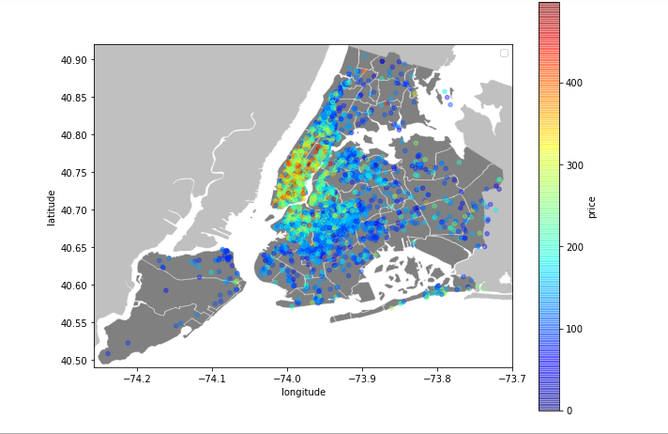

A scatter plot on map depicting the central area to be more expensive in terms of rent than the neighbouring outside of NY city as a whole.

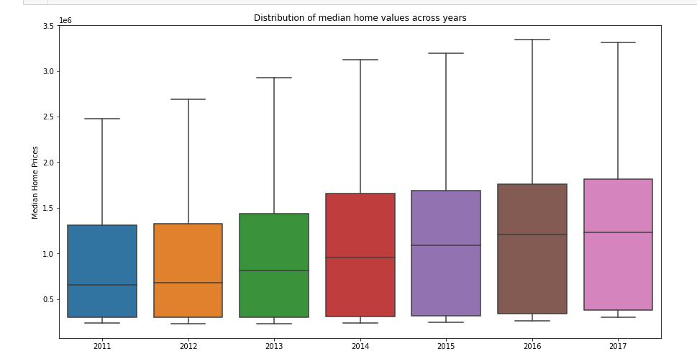

The above distribution is taken from Zillow data by taking a median of all the houses over the span of 8 years starting 2011 to 2017. The general trend is seen to be increasing over the years.

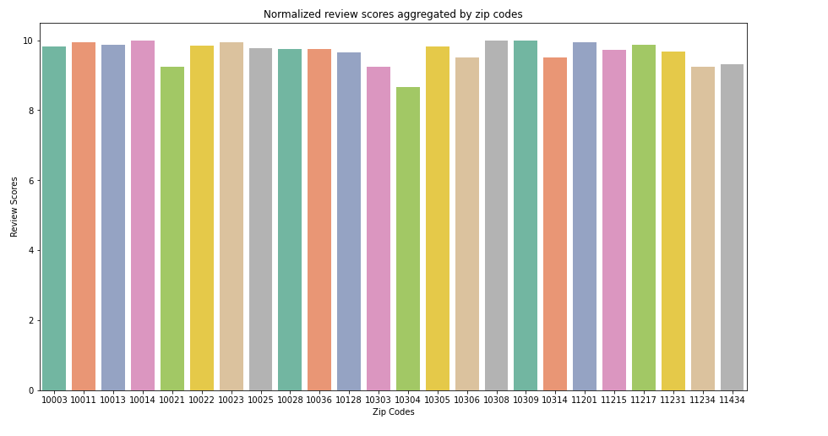

Taking the common values from both the datasets we collect the zipcodes and observe reviews for them. The value of reviews seems to be above average for most of the zipcodes as depicted. 10304 is comparatively less scoring than the others.

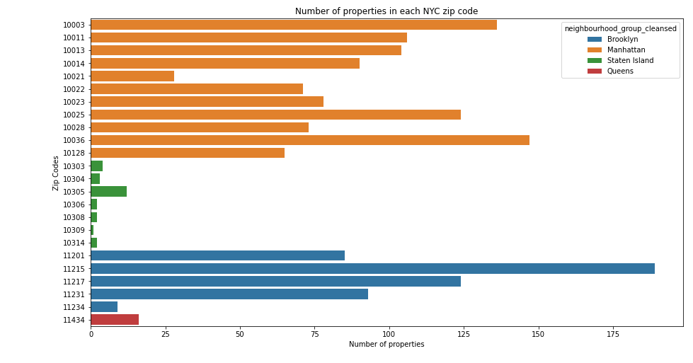

Clearly, Brooklyn and Manhattan seem to occupy majority of the properties in the specified zip codes.

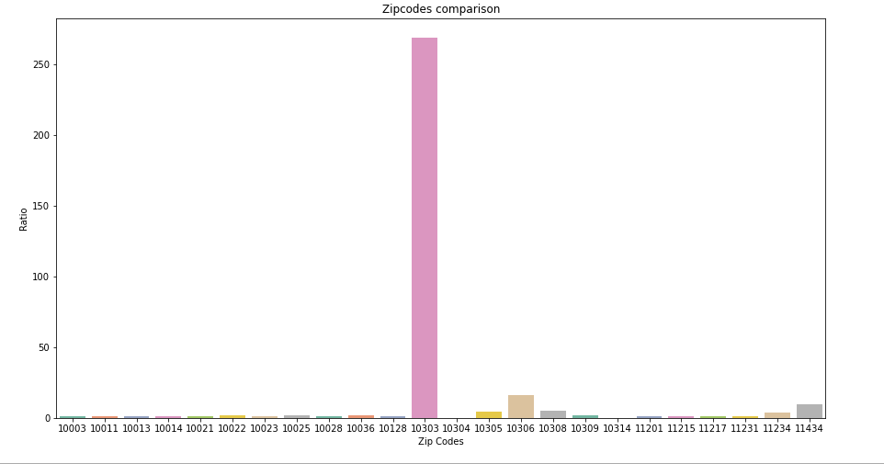

We see 10305, 10306, 10308, 11234 ,11434 seem to be a good fit for investment with more rent/price ratio meaning an investment in these areas will give more return on 2 bedroom apartments rent than other zipcodes.

**What we could do next:** Given the data for Zillow for anywhere near 2019, we could complete the time series analysis to predict a value for the property prices in that year. Considering factors like nearby location and perform analysis on the nearby transit facilities available as that will add to the locality demand and help understand the cause of prices increase and decrease.